C4 To Your Door

*Understanding Hip-Hop and Violence*

George Reynolds

*Brown University*

December 10, 2016

Abstract

Does Hip-Hop encourage violence? Laboratory experiments suggest that the genre does lead to negative behavior. There is also fieldwork on the effects of pornography on sexual violence (Bhuller, Havnes, Leuven and Mogstad 2013) that suggests media may affect violence. Using Billboard’s Hot 100 top 20 songs, I analyze the issue by comparing the number of violent words in Hip-Hop lyrics on Rapgenius.com with the FBI’s Uniform Crime Reporting (UCR) Program violent crime data. In addition, I consider specific cases of exceptionally violent songs and violent crimes committed immediately before and after them. Finally, I compare crime trends in a high Hip-Hop penetration city—Chicago—with those in a low Hip-Hop penetration city—St. Louis. While initial analysis suggests a positive, significant relationship, results do not hold up to falsification tests. Two possible explanations are generally aggressive lyrics, rather than explicitly violent ones alone, leading to violent crime or alternatively, reverse causation.

**Introduction:**

Does violence depicted through Hip-Hop lead to violent crime? Political personalities such as Bill O’Reilly[1] and Juan Williams[2] have scolded the music for glorifying and encouraging violence (among other unwholesome behavior). In recent memory, criticism for artist Kendrick Lamar’s performance on top of a police car during the 2015 BET awards and Beyoncé’s “Formation” performance at 2016 Super Bowl stand as examples of the phenomenon. With this pervasiveness in the American consciousness, the question carries import for policy discussion regarding censorship, analysis from pundits and the ways in which communities interact.

Using data from the FBI’s Uniformed Crime Reporting (UCR) program, Billboard Hot 100 rankings of Hip-Hop songs, Rapgenius.com’s archives of Hip-Hop lyrics and Google Trends data, I attempt to answer the question. I perform regression analysis on the effect of the number of violent words in popular Hip-Hop songs with the number of violent crimes nationally, both with and without weights for the rank of the songs. During this discussion I give particular focus on several especially noteworthy Hip-Hop songs to give specific examples of the effects of encouraged violence on actual violence. I then compare trends of the violent crime rate in a high Hip-Hop penetration city—Chicago—and a low Hip-Hop penetration city—St. Louis.

Key assumptions made are that if Hip-Hop encourages violence, more violent lyrics encourage more of it; if Hip-Hop encourages violence, it will have a larger effect on high Hip-Hop penetration areas; Google Trend data on the query “Hip-Hop” accurately represents Hip-Hop penetration; Google Trends from 2004-present are representative of music taste from before this period; and there is nothing that I have not controlled for that is correlated with both Hip-Hop lyrics and crime in a given time period.

This paper builds on previous work done by Bhuller, Havnes, Leuven and Mogstad (2013), Dahl and DellaVigna (2009) and Kistler and Lee (2009), among others. The first paper cited treats the effect of the Internet (especially pornography) on sexually violent crime. The second treats the effects of violent movies on violent crime. The third treats the effect of Hip-Hop music videos on sexual attitudes. Kistler and Lee 2009 found that Hip-Hop with highly sexual content led to increased objectification of women, along with other effects. My paper builds on the study, along with several other papers that research the effect of Hip-Hop on people in a lab setting, by seeing if the phenomenon of Hip-Hop affecting behavior in negative ways extends to the field. It builds on the former two papers by exploring the effect a new form of media on violence. There is not a clear consensus between the two papers, as Bhuller, et al found a positive effect of the internet and pornography on sexually violent crime, and Dahl and DellaVigna found a negative effect of violent movies on violent crime. This paper contributes to the general question of media effect on violence. It also represents a particularly unique case compared to the other papers discusses, as music can be consumed during other activities and very quickly. Movies and pornography represent much larger commitments, taking considerably more time to consume and being unlikely to be consumed during other activities.

Initial regression analysis suggests that an increase of one violent word in Hip-Hop music a month correlates to an increase of approximately 77 and one-third violent crimes. However, results do not hold under a falsification test. There seem to be two possible explanations. The first is that Hip-Hop music may encourage violence, but not through only explicitly violent lyrics. Further analysis on the effects of generally aggressive lyrics seems necessary. Second, this may be a case of reverse causation. A Hausman test using total words per month as an instrument seems appropriate.

**Data:**

For data on violent crime, I accessed the FBI’s publicly available UCR program data. I used the program’s national report of violent crime offenses from 2000-2006 for national measures. Through 2004, UCR reported what percentage of crimes occurred during specific months. Using these percentages in conjunction with the total number of violent crimes reported, I created estimates of violent crimes on a monthly basis (I say estimates because at times this led to fractions of crimes committed, which is obviously an impossibility). Figure 1 shows a plot of violent crimes committed from January of 2000 through December of 2006. It should be noted that, beginning in 2005, UCR stopped reporting the monthly percentages for violent crimes committed. As a proxy for these rates, I took the average of percentages of violent crime for each month from 1991 through 2004 (while UCR data from 1991-1994 is not on the FBI’s website, the 1995 report does give the percentages for months from these years). I also made use of the program’s city reports for my city comparison. 1995-1999 data was used to compare the trajectories of the cities’ respective violent crimes rates before the time period in question (2000-2006).

Figure 1:

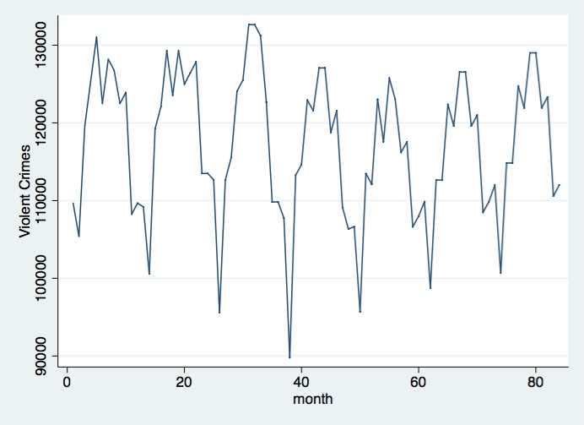

Violent Crimes reported from January of 2000 (month 0) through December of 2006 (month 84)

For data on penetration of Hip-Hop on my comparison cities, I used Google Trends. I used the trends of the search term “Hip Hop” as a proxy for actual Hip-Hop penetration. Results showed that the term was searched more than eleven times as frequently in the Chicago Metropolitan Statistical Area (MSA) as in the St. Louis MSA. Figure 2 shows the Google Trend comparison between the areas. It should be noted here that for violent crime data, I looked at the specific cities rather than the MSAs. UCR had more accessible data on the cities, and Google Trends on the MSAs. I have assumed that the cities and MSAs would have the same general search query levels.

Figure 2:

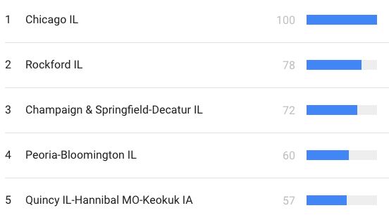

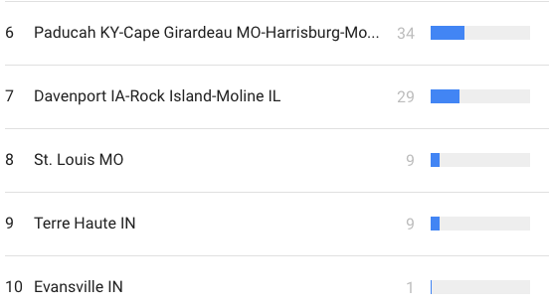

Google Trends for “Hip Hop” in Chicago (row 1) and St. Louis (row 8)

Prior to beginning research, I put together a list of violent words. The list is as follows: Murder, Rape, Kill, Shoot, Gun, Glock, Blood, Crip, Stab, Bleed, Stomp, Pimp, Gang, Choke. I then made us of Rapgenius.com’s archives of song lyrics to record the number of violent words in each song in my sample. Variations of words (i.e. murdered or gangster) were also included in the analysis. Figure 3 provides several examples of word counts for songs.

Figure 3:

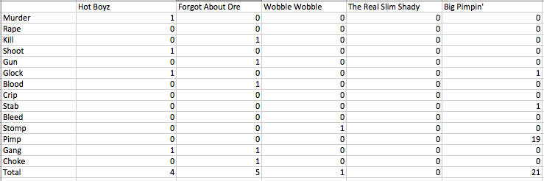

Number of violent words in “Hot Boyz,” “Forgot About Dre,” “Wobble Wobble,” “The Real Slim Shady,” and “Big Pimpin’”

For data on the penetration of specific Hip-Hop songs at large, I used Billboard’s Hot 100 list. I looked at the first list given of each month, with the assumption being that for a song to affect the number of violent crimes for a month, it would have to come at the beginning of the month. Billboard Hot 100 makes use of Nielsen data on music consumption and takes into account record sales and radio playtime (currently, it also takes streaming data into account, but this data does not apply to my time frame). I used only songs in the top 20 of the list. It should be noted that one song was thrown out of the sample: The Blacked Eyed Peas’ “Where Is The Love?” Given that the song uses multiple of the words on my list but to decry rather than condone violent action, it seemed unreasonable to include it when it likely had the opposite effect of that which would be recorded.

In order to control for demographic variables, I used US Census data and US Census point estimates. I made use of the data on race and age. Unfortunately, this data was on a yearly, not monthly, basis. Each month within the year was assigned the values given for the year.

There are several limitations to these data sets. First, the United States is not known for having the most reliable crime data. Even assuming it is 100% accurate, there is still the issue of my having to estimate the percentage of total annual crimes committed per month for 2005 and 2006. There are even larger issues with data for my comparison cities. Violent crime data was only available at the yearly, not monthly level, and demographic data was terrible. The lack of statistics on age and racial composition of the cities made it virtually impossible to control for demographic variables, making it difficult to claim full knowledge of Hip-Hop’s effect in these areas. Further, the UCR Program deemed Chicago’s reported statistics on rape unreliable. To deal with this, I threw out the St. Louis stats on rape and made the assumption that the trend of rape offenses would generally be the same as the trends violent crime not including rape for the two cities With regards to violent words, there is the issue of violent words being counted in non-violent situations (i.e. a rapper could say something along the lines of “I killed the track,” which does not necessarily correlate to encouraged violence). The hope here is that there are enough examples of encouraged violence that does not make use of these words (i.e. a rapper could say “I will strangle you to death,” and it would not register on this list) to balance out.

With regards to the Google Trend data, there is the issue of a lack of units. Google Trends gives relative, not absolute ratings. For this reason, while Chicago had a much higher score than St. Louis, it is possible that these are both at one extreme of the spectrum and closer than they would appear.

**Methods**:

In my attempt to see the effect (if any) of violence in Hip-Hop music on violent crime, I begin by looking at the national level. Initially, I run a regression analysis of the effect of the number of violent words in top 20 Billboard Hot 100 in a month on the number of violent crimes in the same month. As a falsification test I also conduct regression analysis of the effect of the number of violent words in top 20 Billboard Hot 100 in a month on the number of violent crimes in the *previous* month. In both regressions I control for race and age. I control for race by using variables for the percentage of the population that is white and the percentage of the population that is black. I control for age by using variables for the percentage of the population between the ages of 15 and 19, the percentage of the population between the ages of 20 and 24, the percentage of the population between the ages of 25 and 29 and the percentage of the population between the ages of 30 and 34. I control for younger parts of the population based on the assumption that people these ages are more likely to commit crimes. The model for my regression analysis of the effect of violent words per month on violent crimes per month is:

VCt =

Where VC represents Violent Crimes in a given month, VW represents the number of violent words in Hip-Hop songs in the Billboard Hot 100’s top 20 in a month, race represents a two-variable vector containing the previously discussed racial controls, age represents a four-variable vector containing the previously discussed age controls, month represents a twelve-variable vector containing dummy variables for each month to provide a seasonal control, year is an indicator variable for the year (with 2000 being year 1), and $ε_{it}$ representing my error term.

The model for my regression analysis of the effect of violent words on the previous month is:

VCt-1 =

Where all variables are the same as the regression model for the effect of violent words per month on violent crimes per month. The subscript for VC, t-1, demonstrates that the regression analysis is for violent crimes from the previous month.

Next, as a robustness check, I look into the effect of violent words when weighting words based on the ranking of the song, in order to afford songs with larger popularity in the country a larger value of “encouraged violence.” The model for encouraged violence in a month is as follows:

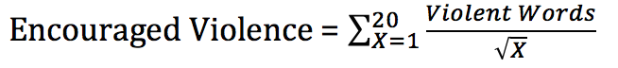

I then use a log-linear regression to explore the effects of encouraged violence in a month on violent crimes in a month. This regression model is as follows

log(VCt) =

Where EVM represents encouraged violence for a given month. I made use of the log-linear model due to the abstract nature of the variable of encouraged violence. I then follow the same falsification test of running regression analysis of the effects of encouraged violence on the previous month’s violent crimes.

Next, I look at specific cases of particularly noteworthy songs. Thesesongs are “Always On Time” by Ja Rule, “Gangsta Lovin’” by Eve, “Lean Back” by Terror Squad, “Drop It Like It’s Hot” by Snoop Dogg, “Hate It Or Love It” by The Game, “Pimpin’ All Over The World” by Ludacris and “Ridin’” by Chamillionaire. These songs are used as case studies for songs that especially encourage violence, as they are the only ones with a measure of encouraged violence two standard deviations or more above the mean of the total sample of songs. I look at the trend of violent crimes per month six months before and after these songs were in the top 20 of Billboard Hot 100. If Hip-Hop music does encourage violence, then we would expect to see violent crime sharply increase after these especially violent songs reached high popularity.

Finally, I compare the violent crime rates in St. Louis and Chicago before my sample begins and during it.

**Results:**

To begin, regression analysis of the effect of the number of violent words in Hip-Hop songs in the top 20 of Billboard’s Hot 100 yielded the following results:

|  |  |  |  |  |
| --- | --- | --- | --- | --- |
| Independent Variable | Coefficient | Standard Error | t | P>|t| |
| Violent Words in the month | 77.32003 | 12.949915 | 5.97 | 0 |
| % White | 150396.5 | 19888.17 | 7.56 | 0 |
| % Black | 774334.6 | 218455.2 | 3.54 | 0 |
| January | -14949.37 | 394.4415 | -37.9 | 0 |
| February | -27508.45 | 401.925 | -68.44 | 0 |
| March | -10120.56 | 400.3811 | -25.28 | 0 |
| April | -9524.885 | 408.6015 | -23.31 | 0 |
| June | -2973.089 | 403.9212 | -7.36 | 0 |
| July | 4291.743 | 430.2655 | 9.97 | 0 |
| August | 2794.536 | 406.446 | 6.88 | 0 |
| September | -2705.389 | 403.6354 | -6.70 | 0 |
| October | -2563.926 | 389.1107 | -6.59 | 0 |
| November | -15378.31 | 390.2379 | -39.41 | 0 |
| December | -15228.42 | 385.4048 | -39.51 | 0 |
| Year | -2303.579 | 339.832 | -6.78 | 0 |
| % Between 15 and 19 YO | 1702280 | 275162.4 | 6.19 | 0 |
| % Between 20 and 24 YO | 0 (Omitted) |  |  |  |
| % Between 25 and 29 YO | -1940828 | 235795 | 8.23 | 0 |
| % Between 30 and 34 YO | -503019.8 | 270612.3 | -1.86 | 0.064 |
| Constant | -299948.7 | 35460.12 | -8.46 | 0 |

Where R2 = 0.9574 and N = 594.

According to this analysis, one violent word in Hip-Hop songs in the top 20 of Billboard’s Hot 100 correlates to about an extra 77 and one-third violent crimes in that month, with the coefficient being statistically significant. While this magnitude seems high, it is also much smaller than the coefficient of any control variable. To test these results, I used the falsification measure described in the Methods section. The results were as follows:

|  |  |  |  |  |
| --- | --- | --- | --- | --- |
| Independent Variable | Coefficient | Standard Error | t | P>|t| |
| Violent Words in the Month | 74.14515 | 13.16429 | 5.63 | 0 |
| % White | 140462.4 | 20218.6 | 6.95 | 0 |
| % Black | 787803.6 | 222084.8 | 3.55 | 0 |
| January | -5747.307 | 400.995 | -14.33 | 0 |
| February | -5410.231 | 408.6029 | -13.24 | 0 |
| March | -18085.38 | 407.0333 | -44.43 | 0 |
| April | -637.8088 | 415.3903 | -1.54 | 0 |
| June | 9501.45 | 410.6323 | 23.14 | 0 |
| July | 6835.004 | 437.4143 | 15.63 | 0 |
| August | 13056.44 | 413.199 | 31.60 | 0 |
| September | 12052.07 | 410.3417 | 29.37 | 0 |
| October | 7167.15 | 395.5757 | 18.12 | 0 |
| November | 6704.827 | 396.7216 | 16.90 | 0 |
| December | -6016.321 | 391.8082 | -15.36 | 0 |
| Year | -1178.212 | 345.4783 | -3.41 | 0 |
| % Between 15 and 19 YO | 1910285 | 279734.2 | 6.83 | 0 |
| % Between 20 and 24 YO | 0 (Omitted) |  |  |  |
| % Between 25 and 29 YO | 2331882 | 239712.7 | 9.73 | 0 |
| % Between 30 and 34 YO | 422673.4 | 275108.5 | 1.54 | 0.125 |
| Constant | -414055 | 36049.28 | -11.49 | 0 |

Where R2 = 0.9579 and N = 594.

The results are virtually the same in both significance and magnitude as compared to the initial regression. In an attempt to parse out the time trends, I plotted the predicted values of the model (for violent crime, not previous violent crime), which fits quite closely to actual values, depicted in Figure 4. Time trends do not appear to be the cause for the multi-directional correlation.

Figure 4:

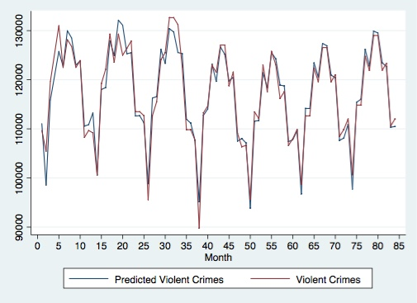

My analysis with weights based on ranking yielded the following results:

|  |  |  |  |  |
| --- | --- | --- | --- | --- |
| Independent Variable | Coefficient | Standard Error | t | P>|t| |
| log(Encouraged Violence) | 0.0036348 | 0.0012265 | 2.96 | 0.003 |
| January | -0.1274997 | 0.0035653 | -35.76 | 0 |
| February | -0.2518056 | 0.0036336 | -69.30 | 0 |
| March | -0.0853114 | 0.0036274 | -23.52 | 0 |
| April | -0.0795694 | 0. 0036747 | -21.65 | 0 |
| June | -0.0254938 | 0.003629 | -7.03 | 0 |
| July | 0.0321125 | 0.0038517 | 8.34 | 0 |
| August | 0.0227214 | 0.0036598 | 6.21 | 0 |
| September | -0.0215889 | 0.0036299 | -5.95 | 0 |
| October | -0.0207021 | 0.0035022 | -5.91 | 0 |
| November | -0.130881 | 0 .003509 | -37.30 | 0 |
| December | -0.1291705 | 0. 0034562 | -37.37 | 0 |
| Year | -0.0253119 | 0.0038719 | 6.54 | 0 |
| log(% White) | 1.383798 | 0.0874552 | 15.82 | 0 |
| log(% Black) | 0 (Omitted) |  |  |  |
| log(% Between 15 and 19 YO) | 1.530371 | 0.2865285 | 5.34 | 0 |
| log(% Between 20 and 24 YO) | 0.909655 | 0.2431323 | 3.74 | 0 |
| log(% Between 25 and 29 YO) | 1.486291 | 0.136214 | 10.91 | 0 |
| log(% Between 30 and 34 YO) | -0.5222641 | 0.197465 | -2.64 | 0.008 |
| Constant | 21.25828 | 1.444777 | 14.71 | 0 |

Where R2 = 0.9558 and N = 594.

There is a positive, statistically significant correlation between a percentage change in encouraged violence in a month and percentage change in violent crime for that month. Specifically, it would predict that a 100% increase in encouraged violence would correlate with about a .4% increase in violent crime nationally. This magnitude is fairly small compared to the coefficients for control variables. My falsification test through a regression analysis on the effect of a percentage change in encouraged violence on the percentage change in violent crime in the previous month yielded the following results:

|  |  |  |  |  |
| --- | --- | --- | --- | --- |
| Independent Variable | Coefficient | Standard Error | t | P>|t| |
| log(Encouraged Violence) | 0.0028945 | 0.0012459 | 2.32 | 0.021 |
| January | -0. 0501525 | 0. 0036217 | -13.85 | 0 |
| February | -0. 0487436 | 0.0036911 | -13.21 | 0 |
| March | -0.1718589 | 0.0036849 | -46.64 | 0 |
| April | -0.0049567 | 0.0037329 | -1.33 | 0.185 |
| June | 0.0787207 | 0.0036865 | 21.35 | 0 |
| July | 0.0560261 | 0.0039128 | 14.32 | 0 |
| August | 0.1087471 | 0.0037178 | 29.25 | 0 |
| September | 0.1011397 | 0.00336874 | 27.43 | 0 |
| October | 0.0604647 | 0.0035577 | 17.00 | 0 |
| November | 0.0580107 | 0.0035646 | 16.27 | 0 |
| December | -0.0517753 | 0.003511 | -14.75 | 0 |
| Year | -0.01417 | 0.0039332 | -3.60 | 0 |
| log(% White) | 1.326155 | 0.0888406 | 14.93 | 0 |
| log(% Black) | 0 (Omitted) |  |  |  |
| log(% Between 15 and 19 YO) | 1.643456 | 0.2910676 | 5.65 | 0 |
| log(% Between 20 and 24 YO) | 0.8711516 | 0.2469839 | 3.53 | 0 |
| log(% Between 25 and 29) | 1.738611 | 0.1383718 | 12.56 | 0 |
| log(% Between 30 and 34) | 0.1046526 | 0.2005932 | 0.52 | 0.602 |
| Constant | 23.66189 | 1.467665 | 16.12 | 0 |

Where R2 = 0.9563 and N = 594.

As in the first round of regression analysis, there is a statistically significant correlation between a percentage change in encouraged violence and percentage change in violent crimes in the previous month. This makes it difficult to interpret the findings as evidence that violent Hip-Hop lyrics are causing violence in the population.

Next, I look at specific cases of particularly violent songs, those with encouraged violence at least two standard deviations higher than the mean of the total sample.

First, I considered “Always On Time” by Ja Rule, which appeared in month 27. The graph is renormalized with month 0 representing month 27.

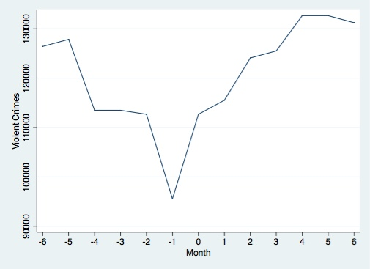

While there is a notable increase after the song’s appearance, there is a steeper one leading up to it, suggesting the song is not the cause of the increase.

The next case looked at was “Gangsta Lovin’” by Eve, which appeared in months 33, 34 and 35. The graph is renormalized with month 0 representing month 33.

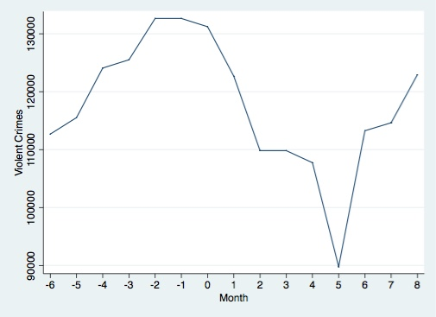

There is again a large increase in violence before the song makes the top 20; however, here there is a decrease, not an increase, after the debut

Next, I considered “Lean Back” by Terror Squad, which was in the sample for months 57 and 58. The graph is renormalized with month 0 representing month 57.

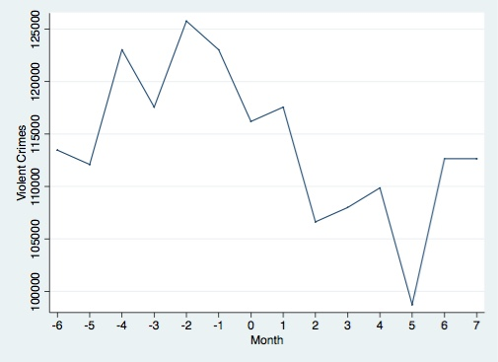

In this case, we see a significant drop off in violent crimes after the song is in the top 20, along with a general increasing trend in violence before it.

The next case considered was “Drop It Like It’s Hot” by Snoop Dogg, which was in the top 20 in month 59, 60, 61, 62, and 63. The graph is renormalized with month 0 representing month 59.

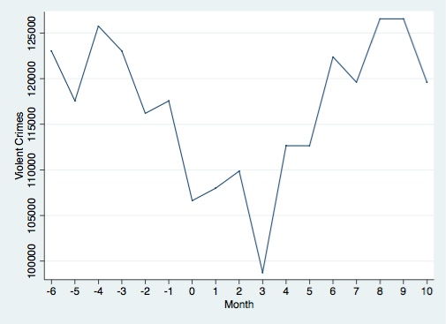

Here, there is an initial increase, followed by a steep decline and then another increase during its reign. Given that the song’s peak ranking is in month 1 and 2 (or 60 and 61), both at number 2, and the decline follows these, it is difficult to view the song as the driver for the increases. There is no pattern of increasing violence before the song’s debut.

“Hate It Or Love It” by the Game, in the sample for month 65, sees a drop-off in crime immediately after its appearance followed by a fairly large increase. There is a dramatic increase in violent crime leading up to the song’s release, followed by a less dramatic one after. The graph is renormalized with month 0 representing month 65.

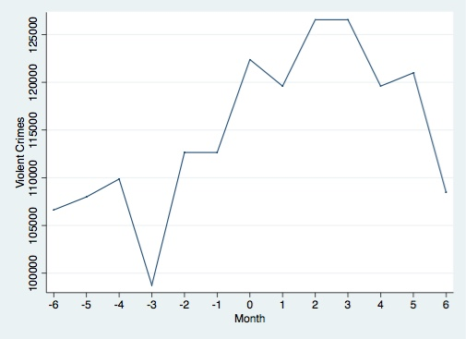

“Pimpin’ All Over The World” is my next case, in the sample for months 68 and 69. The graph is renormalized with month 0 representing month 68. While there is an initial increase in violent crime after month 1 (69), there is then a much larger decrease. There is a much steeper and longer-lived increase in violence leading up to the song’s debut month compared to the small one after its second month.

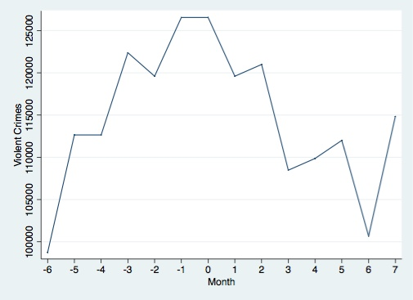

Finally, I looked at “Ridin’” by Chamillionaire, which appeared in months 77 and 78. The graph is renormalized with month 0 representing month 77.

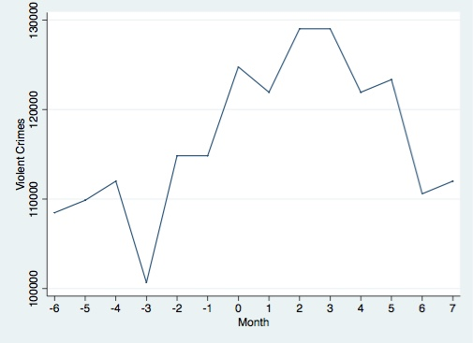

There is an immediate fall-off in violent crimes after the song debuts, but then a larger increase in violent crime after it hits its peak ranking in month 1 (number 1 on Billboard Hot 100). There is a much larger trend of increasing violence before the song’s debut, though.

After considering individual cases, my last part of analysis came with a comparison between St. Louis (my low Hip-Hop penetration city) and Chicago (my high Hip-Hop penetration city). From 1995, their violent crime rates followed these trajectories:

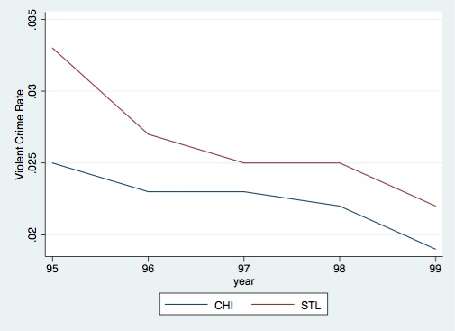Compared to 2000 through 2006: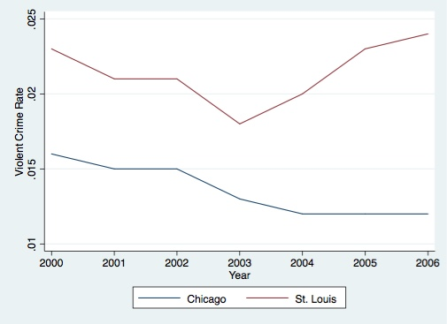

During this time, encouraged violence was as follows:

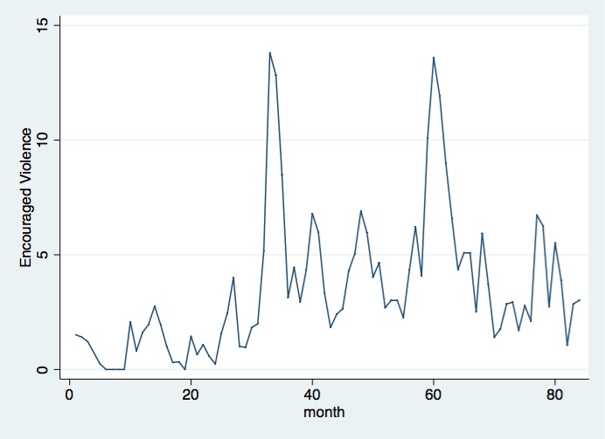

Given the general upward trend of Encouraged Violence from 2002 through 2004, we would expect the city with higher Hip-Hop penetration to see a larger increase in violent crime rate. Instead, we see Chicago experience a violent crime rate decrease and St. Louis experience a violent crime increase, the opposite of what we would expect if violent Hip-Hop music were responsible for violent crime.

Considering the totality of the evidence, it seems unlikely that violence depicted in Hip-Hop legitimately causes violence in society. While both forms of regression analysis showed statistically significant relationships between violent lyrics and violent crimes for a month, there were also statistically significant relationships of virtually equal magnitude between violent lyrics and violent crime from the previous month. Outliers in terms of violent songs are not systematically followed by increases in violence. Interestingly, there was only one case in which the song did not debuta large increase in violence. Finally, the city comparison shows the opposite results of what we would expect if violent Hip-Hop music caused violent crimes. Results do not suggest that violent lyrics in Hip-Hop songs lead to violence in society.

**Discussion:**

There are several limitations of my study. As previously discussed, there are data issues to consider. Perhaps more importantly, I did all of my data calculation by hand, which means there is a larger possibility for human error than in many other studies. There is also the issue of a limited sample. This covers 7 years, and ideally I would have a sample that goes decades, with the middle point being the release of “Rapper’s Delight,” which is often credited for popularizing Hip-Hop.

Aside from these issues that could potentially make illegitimate my conclusions, another serious challenge is the abstractness of my “encouraged violence” measure, which does not have an easily defined unit. Perhaps more concerning is the definition of violence in general, as it is dependent on one list that I put together. Others would likely have come up with a different list of violent terms, which means that this does not necessarily encapsulate encouraged violence as well as it could. My defense to this challenge would be that I have a reasonable enough list that it would likely follow a similar trajectory to any other that someone could come up with. Even if the list does capture the essence of violence, that does not mean the list is perfect. One possible explanation for the results is that violent lyrics alone do not cause violent crime, but generally aggressive lyrics do. Another is reverse causation.

With more time and resources, I would increase my sample significantly, as previously discussed. I would also create an SAS account in order to download SAS to access the NBIRS crime datasets offered online to the public in order to conduct analysis with more granular data to see more immediate effects of violence and violent lyrics. I would perform the same analysis as with this data, but with a new list attempting to capture not just violent, but aggressive lyrics. It is possible that explicit violence alone does not lead to increases in crime, but lyrics that generally increase aggression do. If this phase of analysis yielded similar results, I would compare many more cities than I have, and I would look at the lyrics of songs by rappers from these specific communities to test the idea that violent crime leads to violent lyrics. I would then run a Hausman test to further test reverse causation in the regression model. In order to this, I would collect data on the total number of words in the songs I used in this analysis as an instrument. A larger amount of total words in a song would mean more opportunities for violent words to appear, so presumably cov(words, violent words) ≠ 0. Further, the number of words said would seem to have no bearing on violent crimes unless they were violent and/or aggressive. For example, the lyrics “I ain’t gon stop ‘til I’m finished/ ‘Till I learn Yiddish, or find a little kid who lies spinach/ Can’t nobody beat me in Quidditch” from Asher Roth’s song “CANNON!!!!” would increase a word count by 25 but would not seem to encourage violence.

**Conclusion:**

Hip-Hop lyrics can become quite violent. But there is little evidence to suggest that these lyrics lead to violence at large. City comparisons show opposite trends we would expect if Hip-Hop depicted violence encouraged violence in the population. Regression analysis demonstrates essentially the same relationship between violent lyrics and violent crime in a month as compared to violent lyrics and violent crime from the month before. This, along with large increases in violence before all but one of the exceptionally violent songs and no general trend of increasing violence after them, leave reverse causation as a possible explanation. Many members of the Hip-Hop community have expressed this sentiment in the past, asserting that their lyrics reflect environment. Going forward, I would collect the data on total number of words from the same songs as in this dataset. Using this as data to instrument, I would run a Hausman test to test this explanation. However, before conducting the next phase of testing, I would likely replicate the analysis from this paper, but with the exception of using a list created to capture aggressive lyrics, rather than only explicitly violent.

Bibliography

O’Reilly, Bill. “Harmful Entertainment.” *The O’Reilly Factor.* Fox News, 3 March. 2014. Web.

Williams, Juan. “Songs of the Summer of 1963…and 2013.” *The Wall Street Journal.* Dow Jones & Company. 26. August. 2013. Web.

Dahl, Gordon, and Stefano DellaVigna. “Does Movie Violence Increase Violent Crime?” *Quarterly Journal of Economics,* 124 (2) (May 2009), 677-734.

Bhuller, M. “Broadband Internet: An Information Superhighway to Sex Crime?.” The Review of Economic Studies 80, no. 4 (October 2013): 1237-.

Kistler, Michelle E., and Moon J. Lee. “Does Exposure to Sexual Hip-Hop Music Videos Influence the Sexual Attitudes of College Students?” *Mass Communication and Society* 13.1 (2009): 67-86.

1. O’Reilly, Bill. “Harmful Entertainment.” *Bill* O’Reilly. Fox News, 3 March. 2014. Web.
2. Williams, Juan. “Songs of the Summer of 1963…and 2013.” *The Wall Street Journal.* Dow Jones & Company. 26. August. 2013. Web.